Amazon Message Queue
Amazon MQ is a fully managed message broker service provided by AWS.
It allows applications to communicate with each other using messaging protocols like:
- ActiveMQ
- RabbitMQ
In simple words:
Amazon MQ acts like a middleman that helps different applications exchange messages reliably.

Different systems are working together:
- Mobile App
- Restaurant System
- Payment Service
- Delivery Tracking
- Notification Service
Instead of all services directly talking to each other continuously:
They communicate through a Message Broker.
That broker is similar to:
Amazon MQ

Let’s do a hands-on to understand this better.

Go to Amazon Message Queue
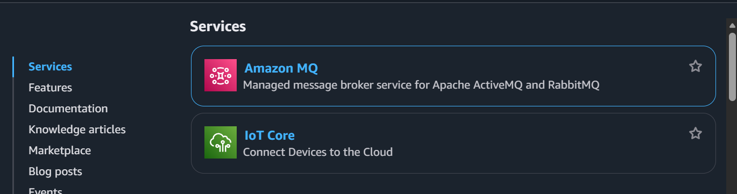
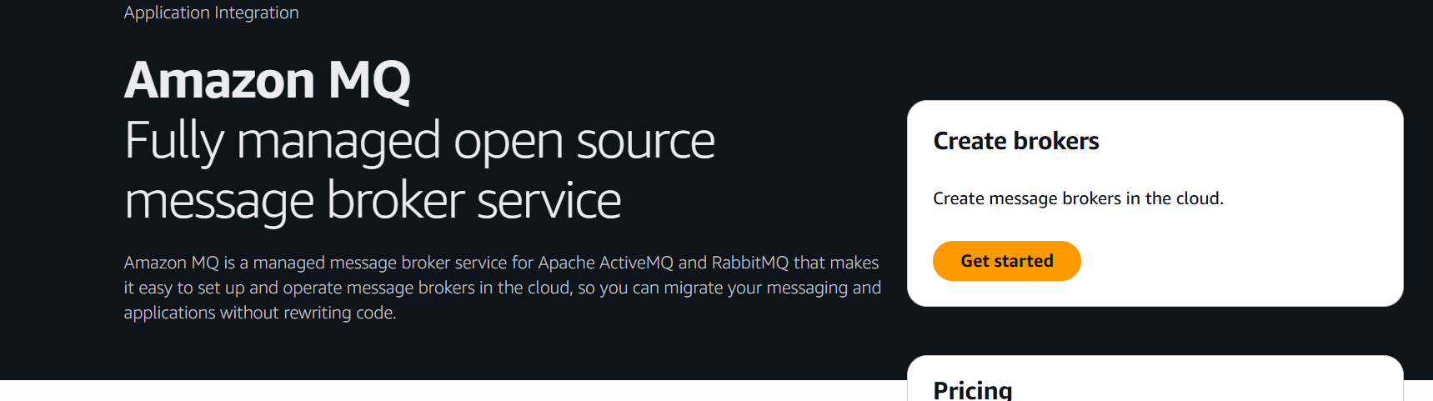
Click on get started
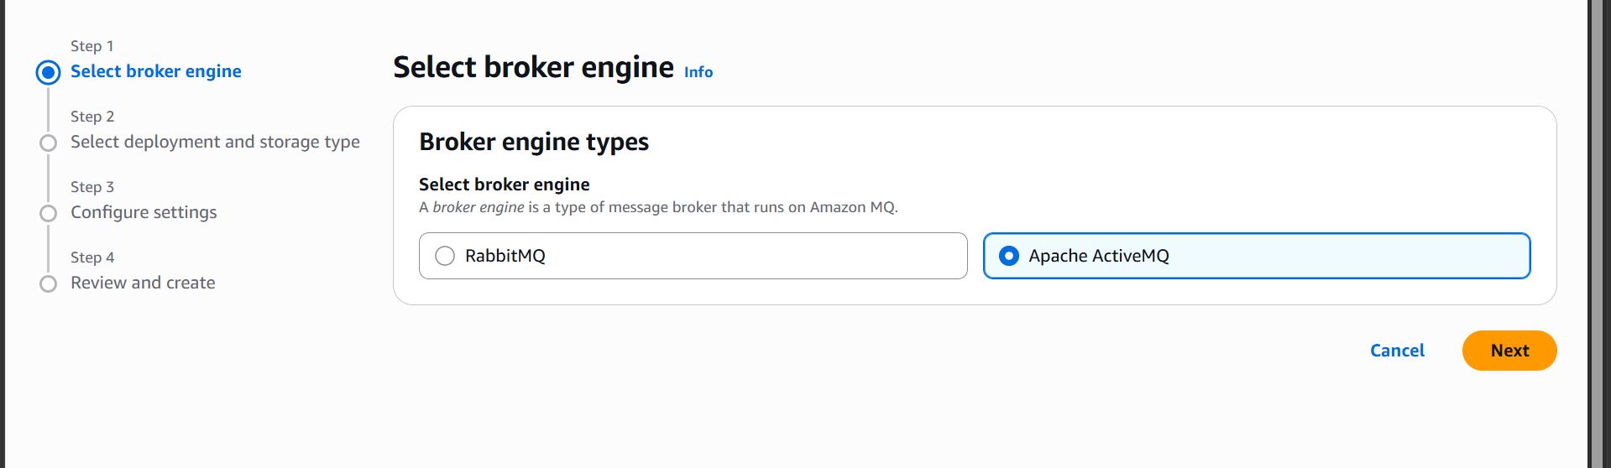
Select a broker engine
Now select deployment type
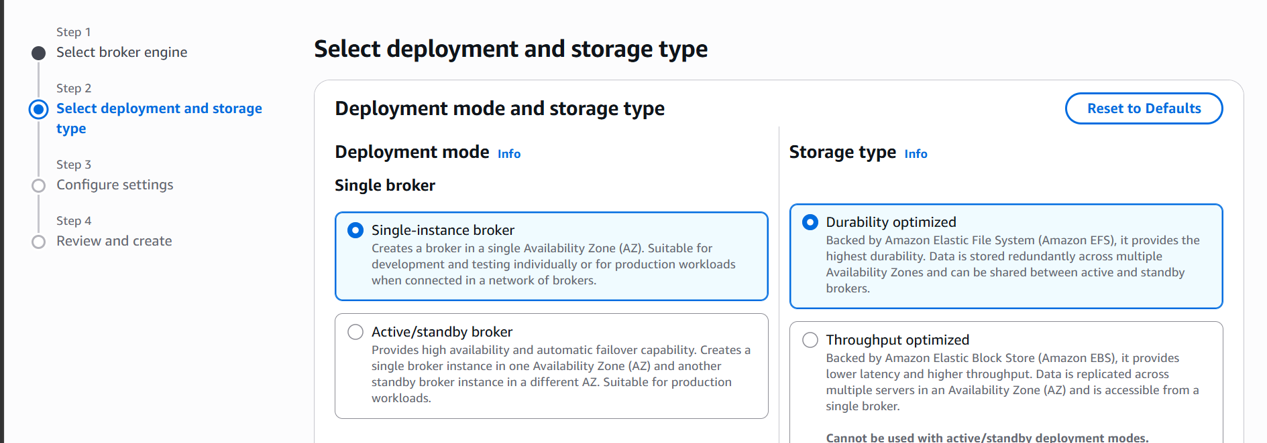

Give a broker name
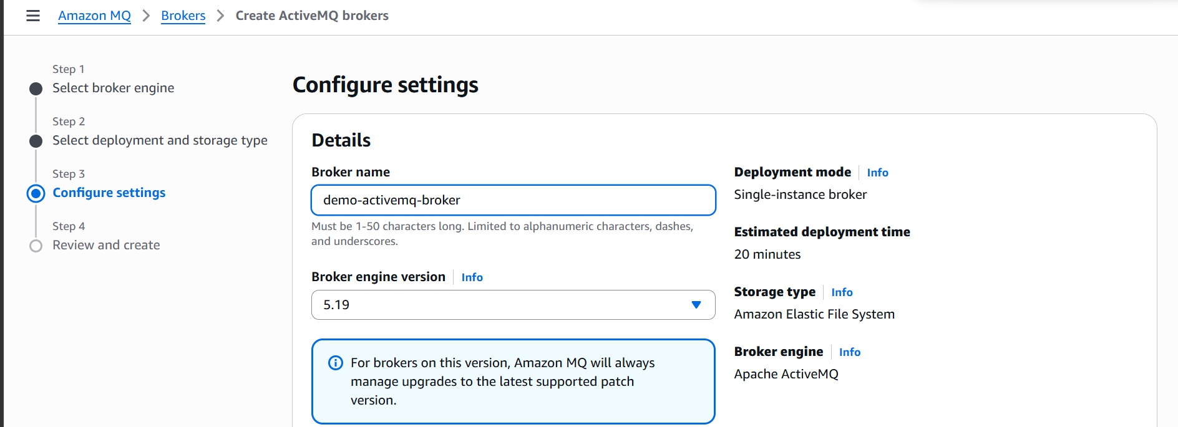

Create username and password
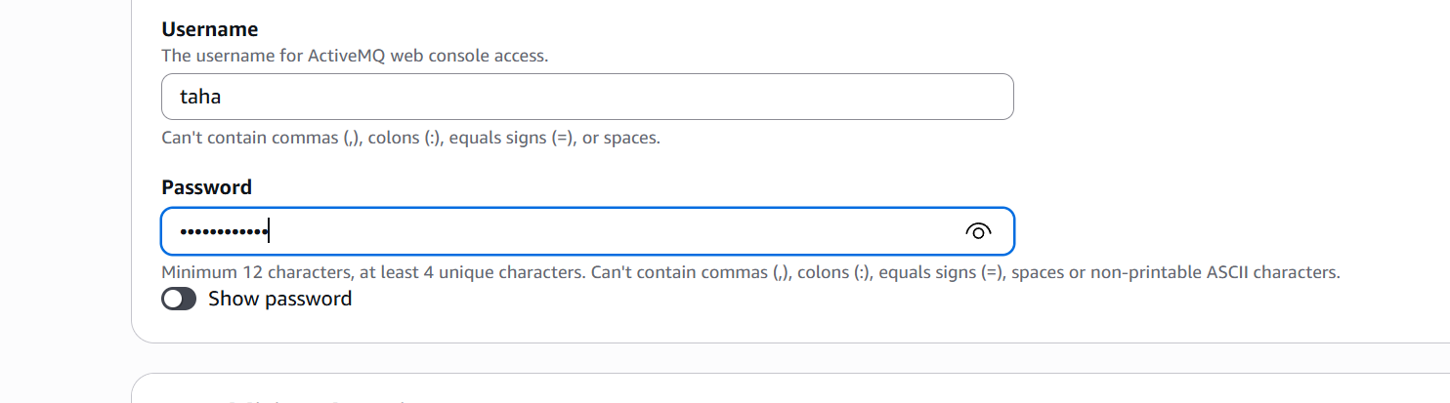
Now click on create
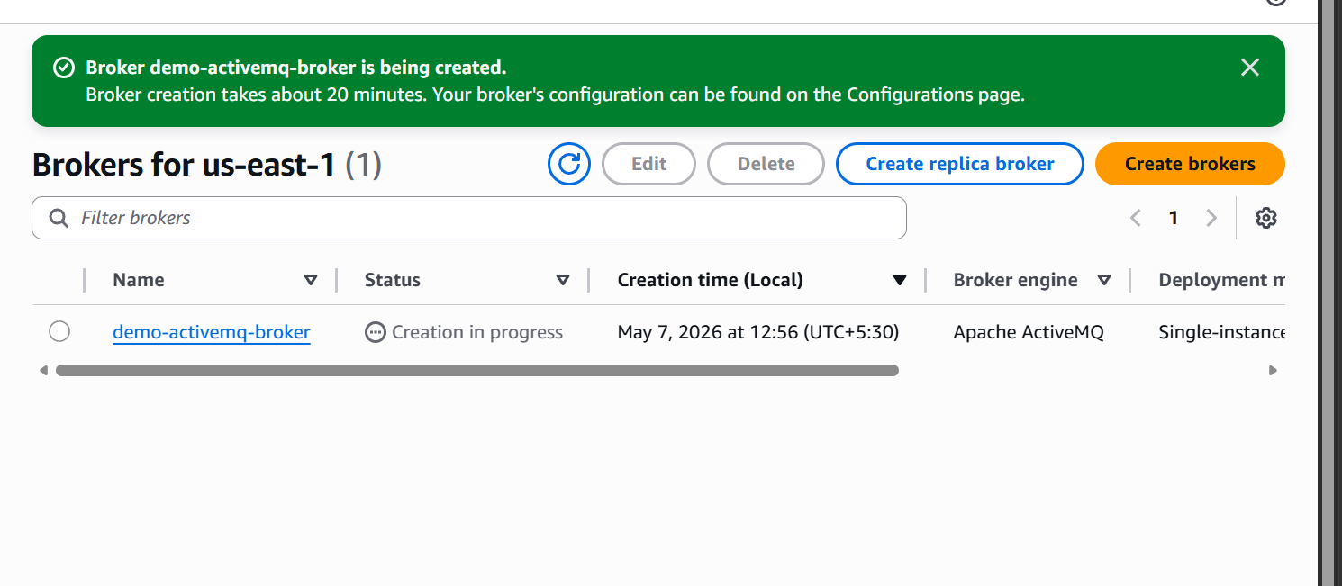

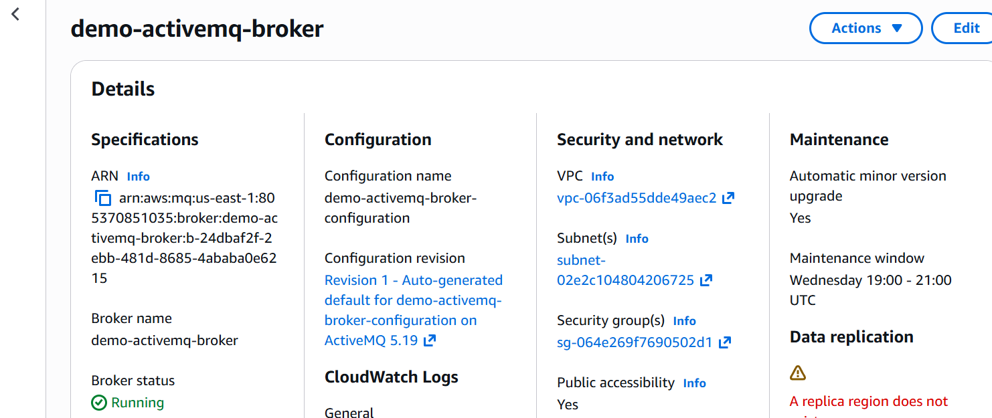

Broker is now running
Now lets go to the broker console
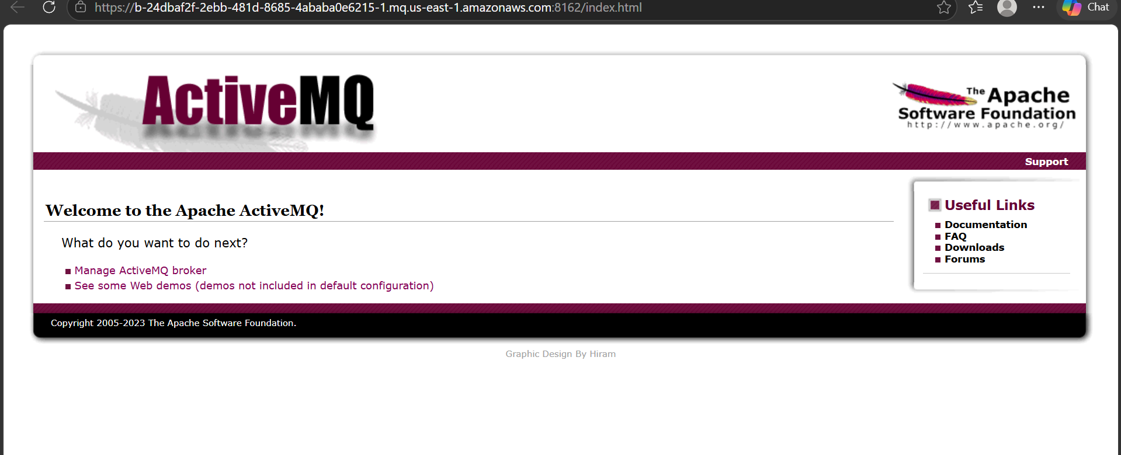

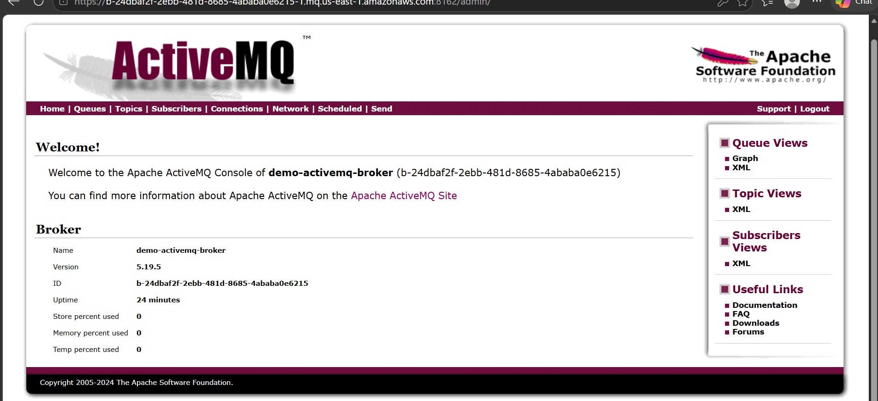

We are now logged in to broker console
Lets create a queue now
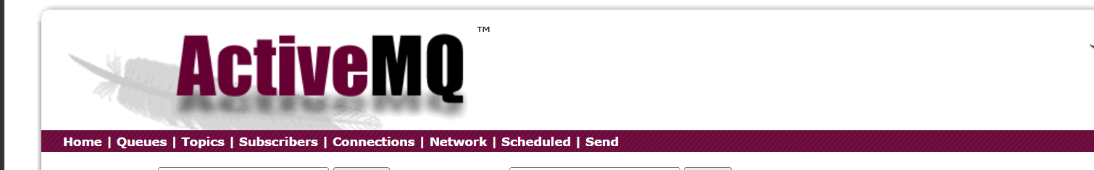
Click on Queues
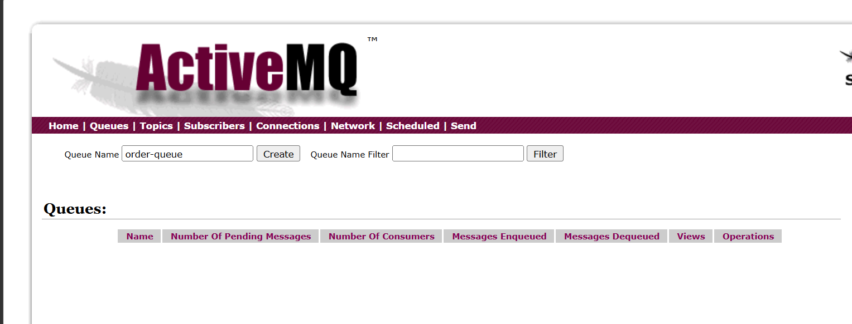
Send a message now
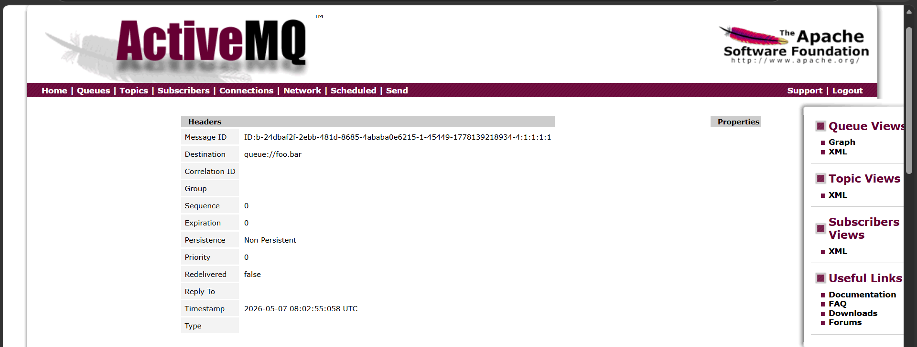

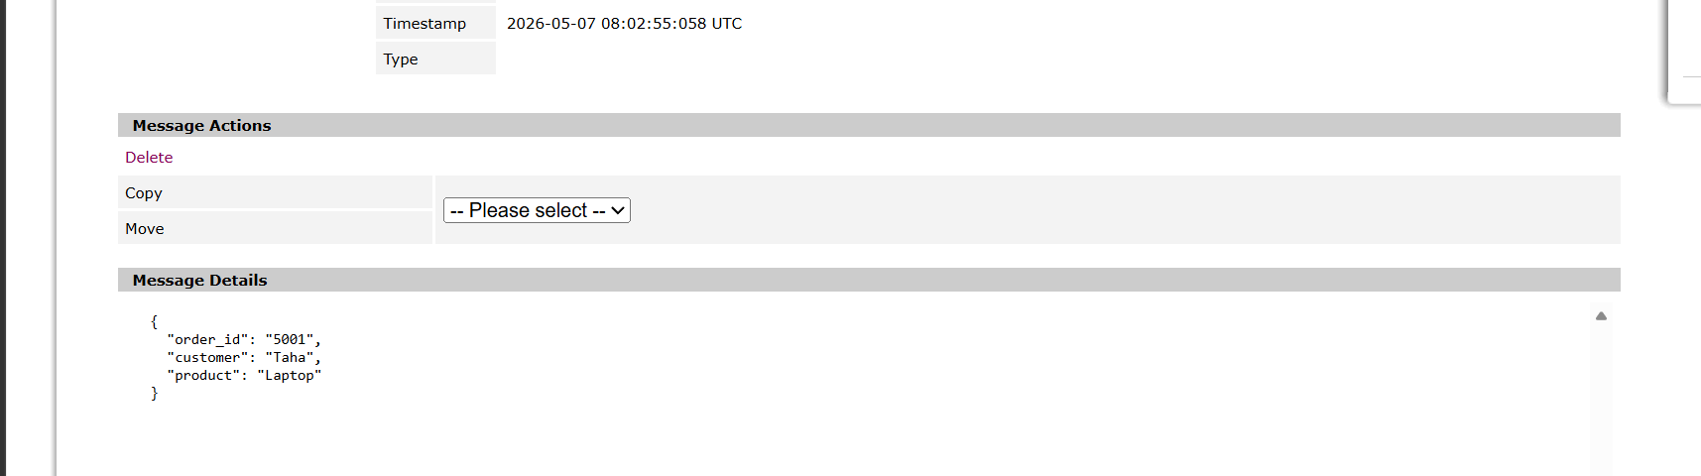

Now we are able to see the full message.

